
Spring25_HW1
Full_adder Design

February 2, 2025
UTD Grad school
Names: Lamin Jammeh (DAL852207) and Caleb Perez (CXP180012)

Project description:
The project is about designing a two-input full_adder in both the structural (Primitive) and Behavioral Model using Verilog HDL. The adder does not require a clock or reset signal. The output is solely dependent on the input. There is no sequential logic or condition between the input and output ports.
Design Testbench:
The same testbench was use for all the three (Structural, Behavioral, and netlist) Verilog design by keeping the Module name for all three design the same. This makes it easy to reuse codes instead of making a new testbench for each version of the adder design.
Testbench code for both Verilog and design and Synthesized Gate netlist:
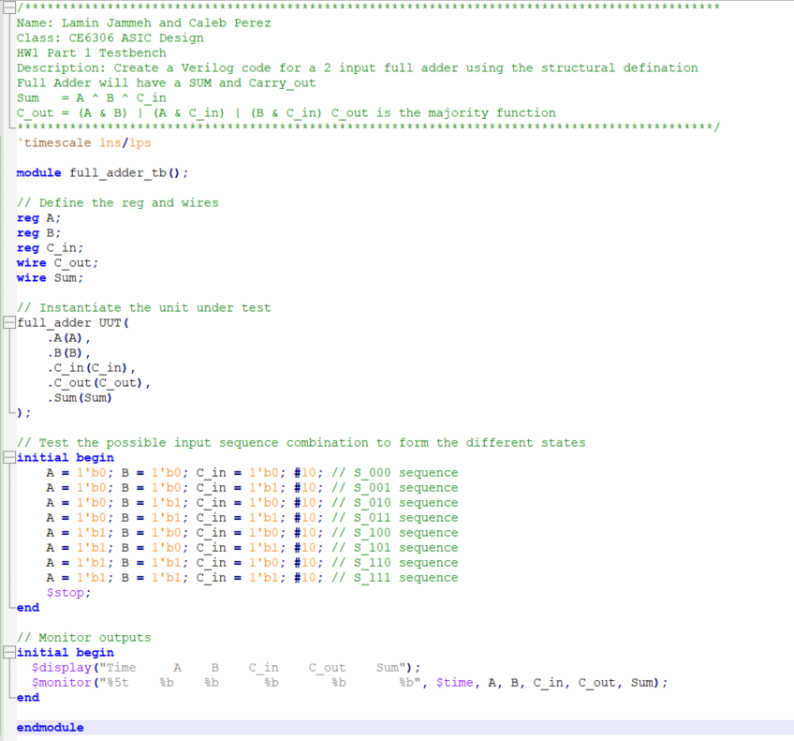
Structural Model:
the structural model of the full_adder in this design assigns a function for the output ports using equation 1 and 2 for the Sum and C_out ports respectively.
$$Sum=XOR(A,B,C_{in})_______________________________________equation1$$
$$C_{out}=\left(A\&B\right) \left(A \& C_{in}\right) | \left(B \& C_{in}\right) __________________________equation2$$
Verilog code for Structural Model:
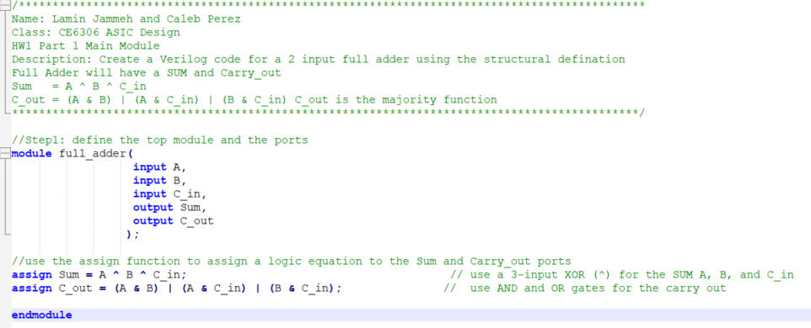
Simulation result for the structural model:
The Simulation was performed in ModelSim_2022.1, the transcript shows how the inputs were change are resulting outputs at the Sum and C_out ports
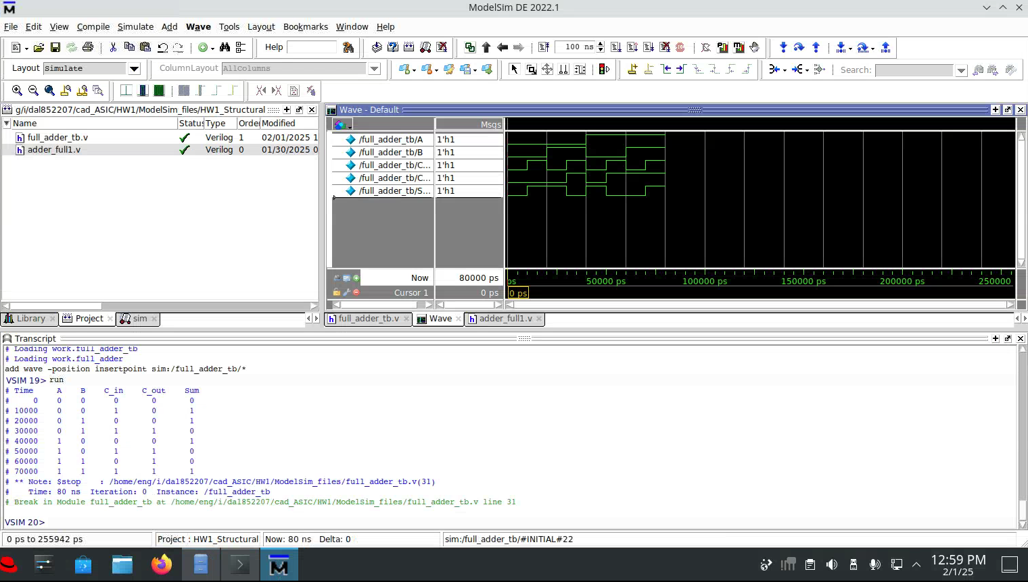
Behavioral Model:
The behavioral model uses similar concept as the structural model, but the out is very dependent on the sensitivity list at the “always block”. The design looks for any change in the sensitivity list and computes the output once a change is detected in the sensitivity list. In this design the sensitivity list includes input ports (A, B, C_in).
Verilog code for Structural Model:
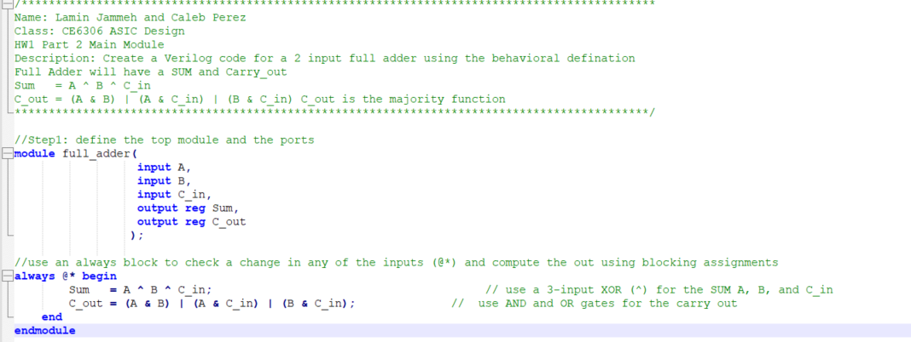

Simulation result for the Behavioral model:
The simulation of the behavioral model is similar to that of the structural model. The table in the transcript are the same and the wave forms are similar
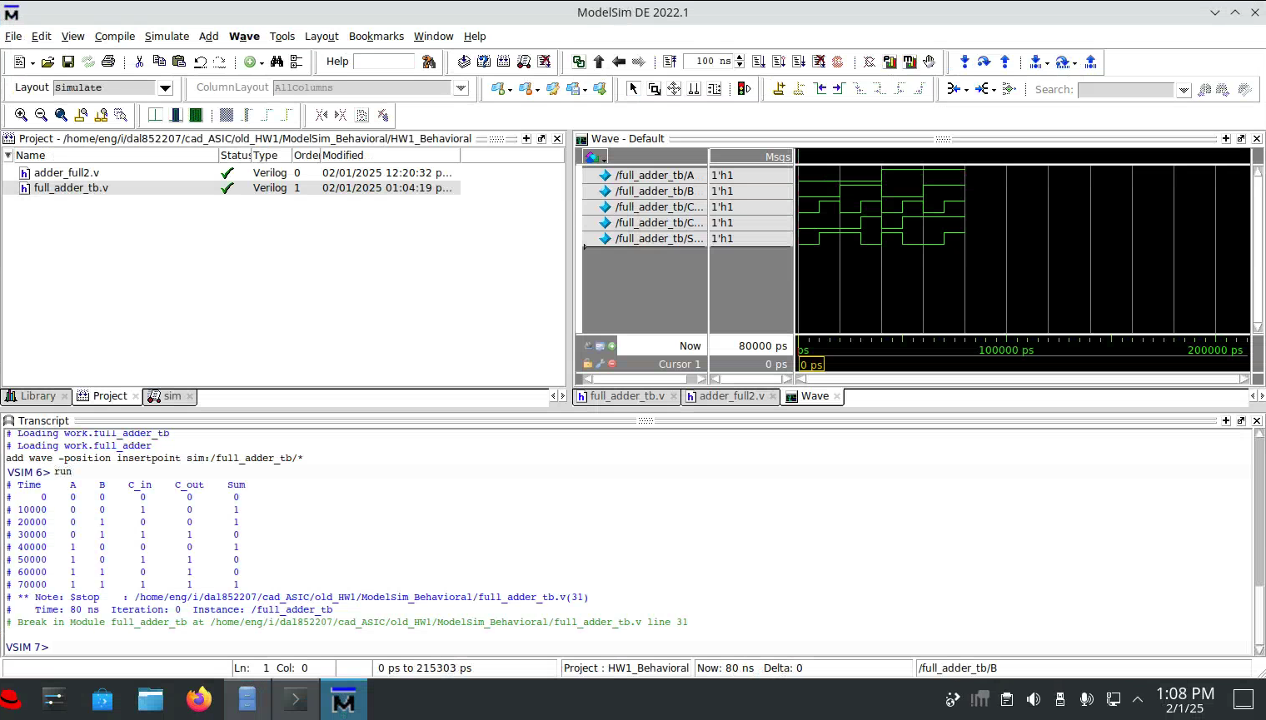
Netlist Model:
The netlist model was obtained by synthesizing the structural module using Synopsys Design compiler. The file for the database used to compile the design and the technology libraries were given for this project. The tcl file was modified to work with our current module
Modified TCL code for design compiler:
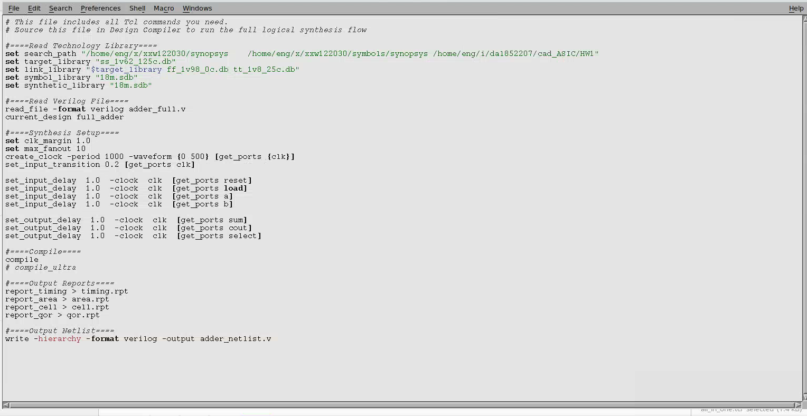
Verilog code for Netlist Model:
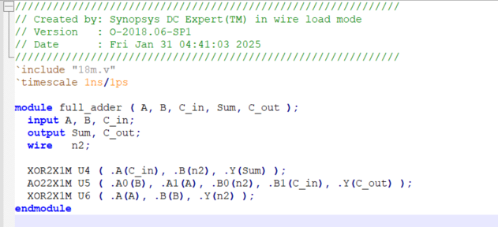
Simulation result for the Netlist model:
The netlist model ran a little slower and it took 2000ps for both output ports to change from uknown (x), but after all the output ports start to register values. The circuit behaved as expected with the C_out showing the majority bits and the Sum showing the XOR (A, B, C_in).

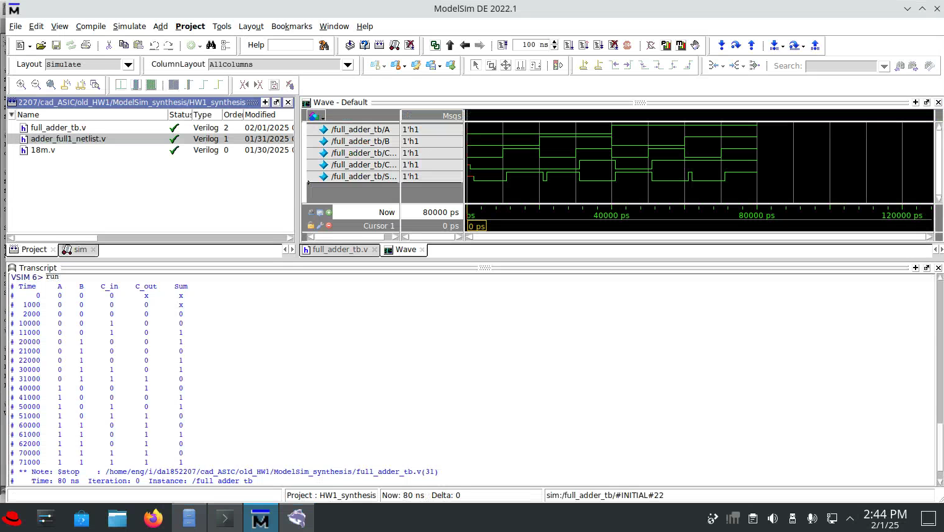

Timing Report from Design Compiler:
